**Documentation for Meesho Power BI Project**

**Project Title:**

**"Meesho Order Analysis Dashboard"**

**Objective:**

To analyze Meesho's forward order data for insights into revenue, shipping costs, and order statuses. The dashboard aims to provide actionable insights for optimizing logistics, improving profitability, and understanding order trends.

**Dataset Description:**

The dataset contains the following columns:

* order_date: The date of the order.
* sub_order_num: Unique identifier for each sub-order.
* order_status: The status of the order (e.g., Delivered, RTO, Cancelled).
* state: The state from which the order originated.
* pin: The pin code of the delivery address.
* gst_amount: GST amount applicable to the order.
* meesho_price: The price of the order.
* shipping_charges_total: Total shipping charges for the order.
* price: Final price after applying discounts and other adjustments.

**KPIs:**

1. **Total Orders:** The total count of sub-orders.

**DAX Function:** distinctcount([‘meesho ForwardReports’[sub_order_num]])

1. **Total Revenue:** Sum of the meesho_price column.

**DAX Function:** sum([‘meesho ForwardReports’[gst_amount]])+sum([‘meesho Forwardreports’[price]])+sum([‘meesho Forwardreports’[shipping_charges]])

1. **Total GST:** Sum of the gst_amount column.

**DAX Function:** sum([‘meesho ForwardReports’[gst_amount]])

1. **Average Order Value (AOV):**  
   **DAX Formula**​: Total Revenue/Total Orders
2. **Total Shipping Charges:** Sum of the shipping_charges_total column.

**DAX Function:** sum([‘meesho ForwardReports’[shipping_charges]])

**Slicers:**

1. **State:** Filters data by state.
2. **Order Date (Date Hierarchy):** Enables filtering by year, month, or day.
3. **Order Status:** Filters data by order statuses (e.g., Delivered, RTO, Cancelled).

**Visualizations:**

1. **State-wise Order Status:**
   * **Type:** Stacked Bar Chart
   * **Details:** Displays the count of orders for each status across different states.
2. **State-wise Shipping Charges:**
   * **Type:** Column Chart with Gradient Colors
   * **Details:** Highlights total shipping costs for each state, using color gradients to emphasize states with the highest costs.
3. **Date-wise Revenue:**
   * **Type:** Line Chart
   * **Details:** Shows daily revenue trends, helping identify peak and low-revenue days.
4. **Top 5 Price-Wise States:**
   * **Type:** Bar Chart
   * **Details:** Displays the top 5 states generating the highest revenue (meesho_price).
5. **Order Status-Wise Details:**
   * **Type:** Pie Chart
   * **Details:** Breaks down the proportion of orders by their statuses (Delivered, Cancelled, RTO).

**Future Scope of Visualization:**

1. **Logistics Analysis:**
   * Analyze average delivery times and identify delayed delivery hotspots.
   * Compare shipping costs vs revenue to highlight states with high logistics expenses.
2. **Customer Insights:**
   * Analyze repeat customers vs new customers.
   * Study revenue and order patterns by pin code or demographic attributes (if available).
3. **Revenue Optimization:**
   * Predict future revenue trends using Power BI's forecasting tools.
   * Visualize profit margins by state by comparing revenue and shipping costs.
4. **Order Trends:**
   * Seasonal and monthly analysis of order volume and revenue.
   * Hourly trends to identify peak order times.
5. **RTO Analysis:**
   * Heatmap for RTO rates by state or pin code.
   * Revenue loss analysis due to RTOs.

**Screenshot:**

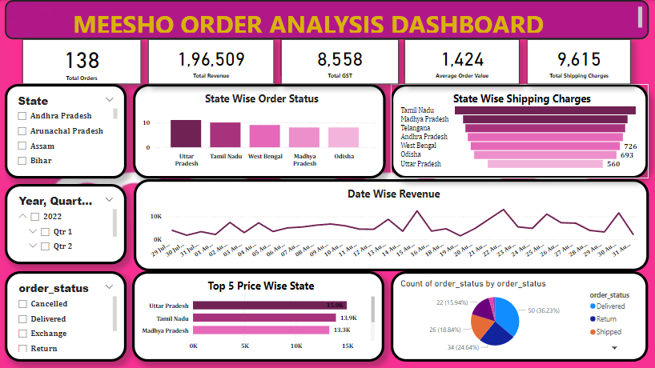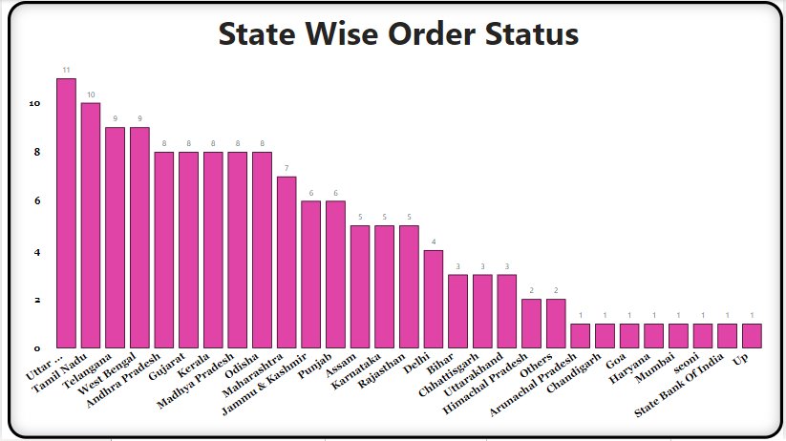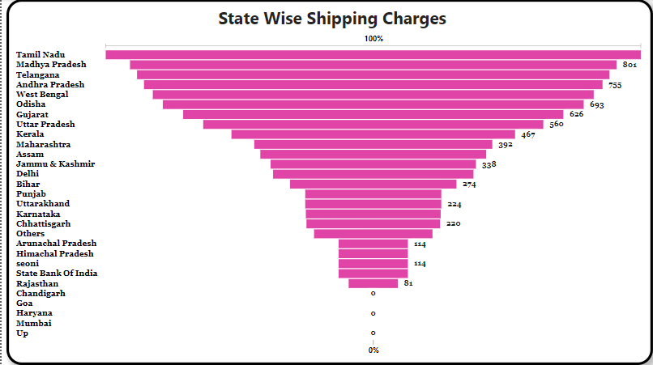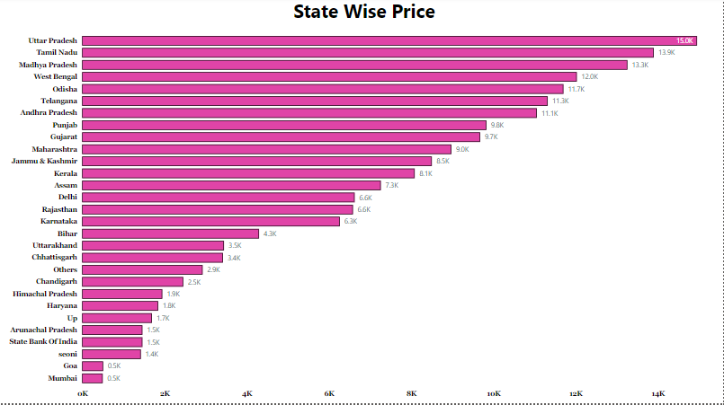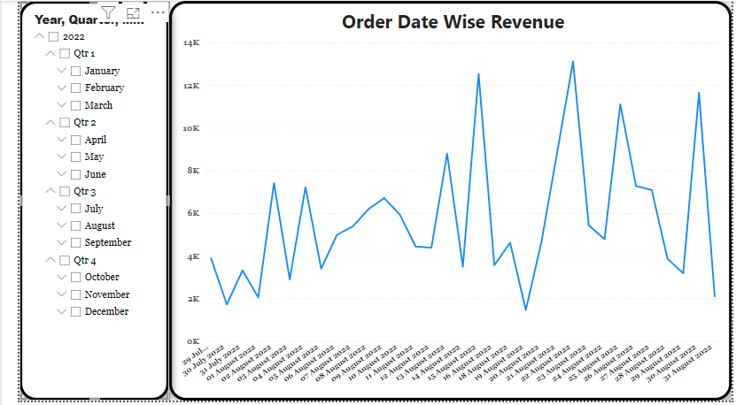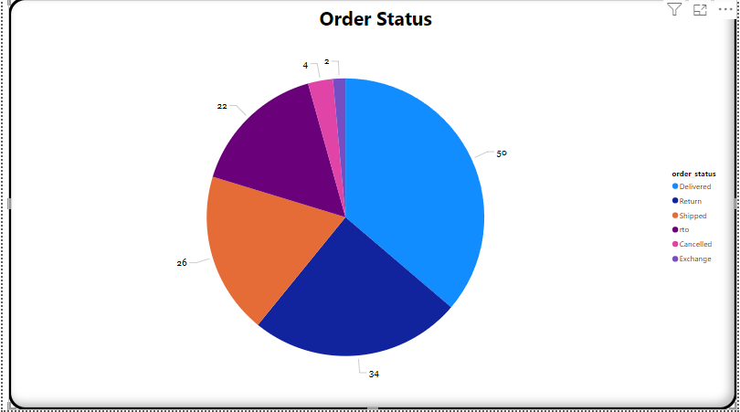

**Conclusion:**

The Power BI dashboard provides a holistic view of Meesho's forward order performance, highlighting critical KPIs and trends. Future enhancements could include deeper customer insights, predictive analytics, and cost optimization strategies.